**Chopta, Uttarakhand**

**Location**-Chopta is a small region of meadows and evergreen forest area, a part of Kedarnath wildlife sanctuary located in Uttarakhand state, India and a base for trekking to Tungnath, the third temple of Panch Kedar which lies 3.5 kilometres away.

**Best time to visit**-Chopta is ideal for vacations all over the year but November to May are the best months to visit.

**Attraction**-Chopta is an unspoiled natural destination lying in the lap of the Uttarakhand Himalayas

The Chopta - Tungnath - Chandrashila trek is a destinations for trekkers. The Chopta region has many treks and trails cutting through jungles and grasslands.

Because of an abundance of birds, Chopta is popular among birdwatchers.

**Activities**-Some activities in Chopta

* Camping and trekking, yoga, survival activity
* Snow trekking, snow skiing
* Rock craft, rock climbing, rappelling
* Photography of rare Himalayan species of [monal bird](https://en.wikipedia.org/wiki/Himalayan_monal" \o "Himalayan monal), [musk deer](https://en.wikipedia.org/wiki/White-bellied_musk_deer) and pika mouse.
* Kund to Deoriatal (3-5 hours trek) - start at Kund, a quaint town situated at 1,350 m, approximately 200 km away from the spiritual town of Haridwar.
* Deoriatal to Chopta (4-5 hours trek)
* Chopta to Chandrashila Peak (4,000 m), via Tungnath Temple and back (4-5 hours trek). The distance from Tungnath Temple to Chandrashila peak is only 1 km and serves as a highlight of the trip. Though the distance is less, it takes time as it is relatively steep.

**Vlog**- https://www.youtube.com/watch?v=pNtcfyB7x60

1st photo:

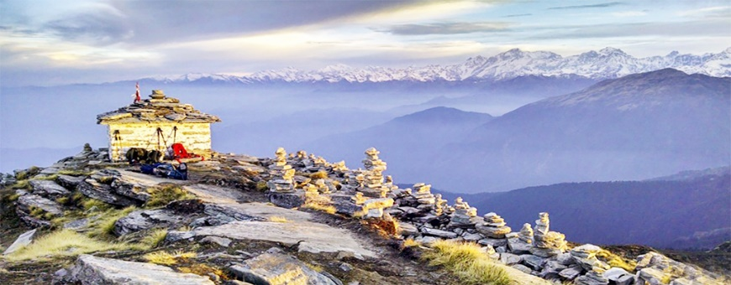

<https://euttarakhandpackage.com/wp-content/uploads/2019/09/chopta.jpg>

2nd photo:

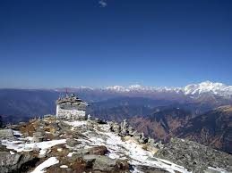

<https://ghumakkadd.com/wp-content/uploads/2017/10/Deoriatal-trekking.jpg>